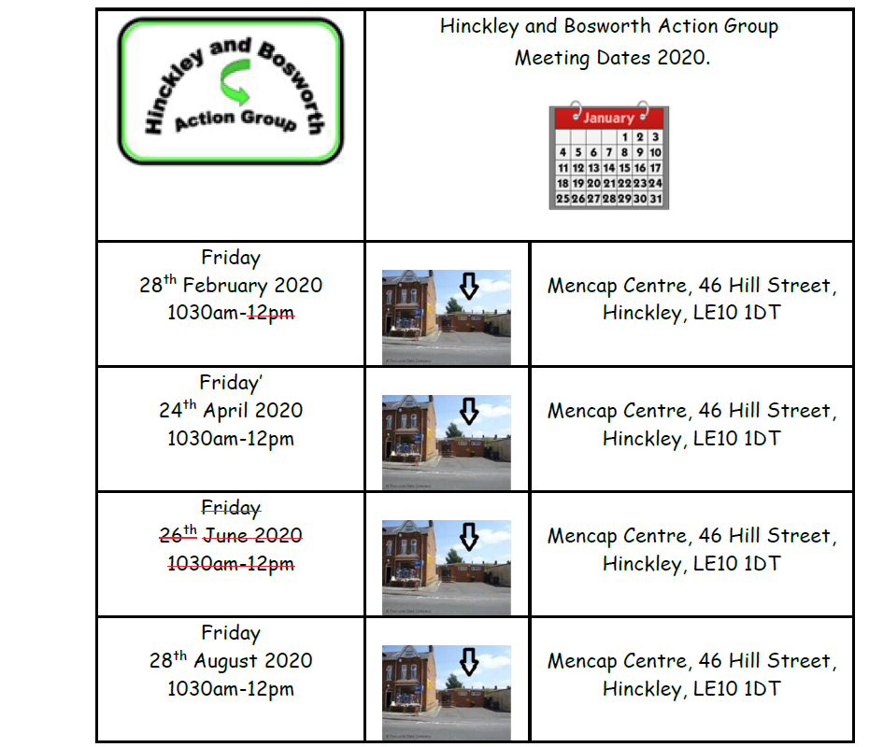

**Learning Disability Friendship Network meeting dates**

8 February 2022

10:30am-12:30PM

14 December 2021

10:30am-12:30PM

12 October 2021

10:30am-12:30PM