

**FREE**

 Staying Safe Online

C:\Users\jsmart\AppData\Local\Microsoft\Windows\INetCache\Content.MSO\36906668.tmp on-line course

Course Code: 20LB915P on 11th May 10-11.30am

Course Code: 20LB914P on 19th May 1-2.30pm

We are spending more time on-line, but do you feel safe?

Have you checked your Online Profile recently? Do you know where to check it? Do you know how to report something that isn’t correct?

Are you worried about being scammed? Are your children and family safe online and how do you know?

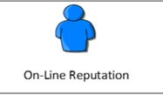

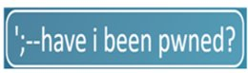Both courses take place on MS Teams and a link will be emailed to you

A strong internet connection is needed

