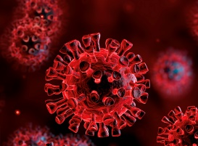
Covid-19 Vaccinations and
People with Learning Disabilities
 | A Learning Disability Nurse can talk with you about the Covid-19 Vaccine.
 | Covid-19 is also called Coronavirus.
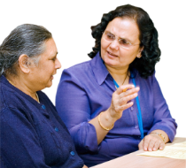 | You can come and talk or ask questions about what Covid-19 is.
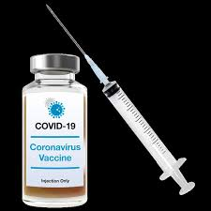 | You can come and talk or ask questions about the Covid-19 vaccine.
 | There may be other people there to talk to.
This will be on a Microsoft Teams Link
On all of these dates:

Thurs 7th Jan 2021
At 12:30pm

Thurs 14th Jan 2021
At 12:30pm

Thurs 21st Jan 2021
At 12:30pm

Thurs 28th Jan 2021
At 12:30pm

For more information

Email: LPT-PCLN@leicspart.nhs.uk

or

Telephone: 07500 993 864

(Siouxie Nelson – Primary Care Liaison Nurse – Learning Disabilities)

