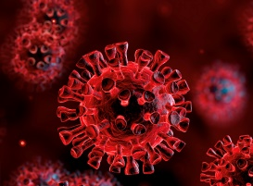
Covid-19 Vaccinations and
People with Learning Disabilities
These informal sessions are for any individual who has a learning disability, family members, paid, voluntary or informal carer’s or provider services (support workers, managers) for people with a learning disability.
This session will be hosted by a Learning Disability Primary Care Liaison Nurse to:
· Discuss the Covid-19 vaccine for people with LD.
· Talk about any issues.
· Discuss reasonable adjustments.
· Support with Mental Capacity Act discussions.
· Share best practice.
Please feel free to drop in or attend weekly
Covid-19 Vaccine and People with LD | Date: 07.01.2021  Time: 12:30 – 13:00  Venue: Microsoft Teams  Click here to join the meeting
Covid-19 Vaccine and People with LD | Date: 14.01.2021  Time: 12:30 – 13:00  Venue: Microsoft Teams  Click here to join the meeting
Covid-19 Vaccine and People with LD | Date: 21.01.2021  Time: 12:30 - 13:00  Venue: Microsoft Teams  Click here to join the meeting
Covid-19 Vaccine and People with LD | Date: 28.01.2021  Time: 12:30 – 13:00  Venue: Microsoft Teams  Click here to join the meeting

We look forward to seeing you there; please contact the Learning Disability Primary Care Liaison Nurses at LPT-PCLN@leicspart.nhs.uk to book your place or to receive the Microsoft Teams link via email, or please feel free to drop in using the MS Teams link above.

