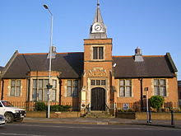   | Action In Melton.  Melton Carnegie Museum  Date: 7 February 2019  Time: 1:30 - 3:30pm

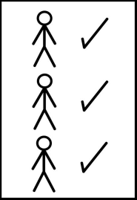  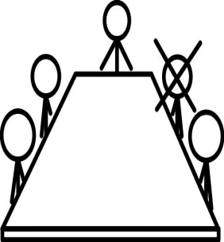 | Present – People who  Heather Yalden  Helen Anderson  Eddie Kolaso  Jackie Goodrick  Claire Summerfield  Yvonne Wanczuk  Marie Moore | came to the meeting  Chairperson  Co-Chair  Self-Advocate  Cert Support  Partnership Board  Mencap  Minute Taker

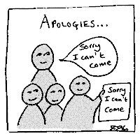 | Apologies – People who could not come  Simnon Bailey  Helen Illsley

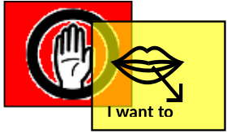 | We used the red and yellow cards  Heather read out the rules

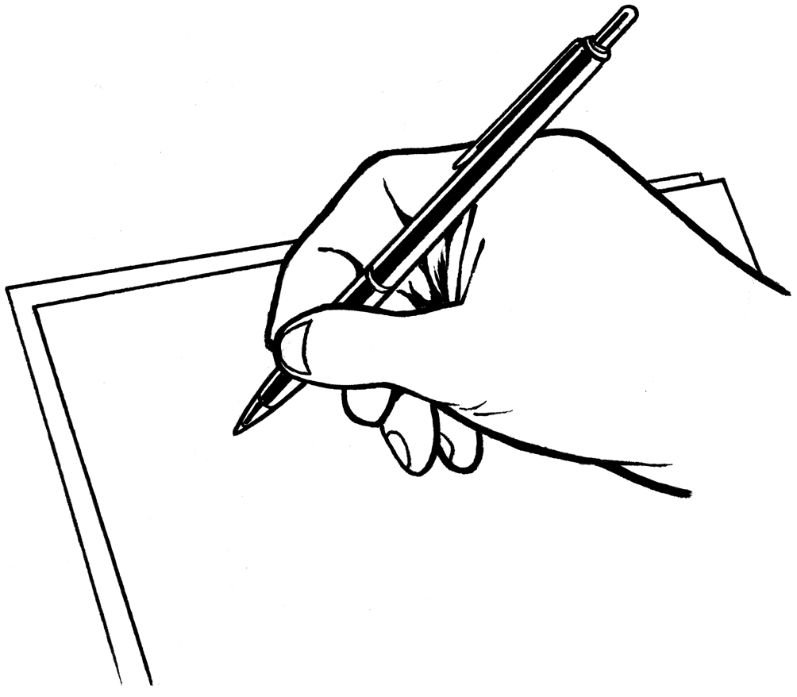   | Notes from the last meeting.  The notes were correct

 | COFFEE BREAK – 15 MINUTES

     | Action Planning:  Jackie talked us through the Action Plan and it was agreed there were some things that we didn’t manage to do which were:  - Cake stall for McMillan  - Sainsbury  - Local Activity Groups and List  - Work Club closed  - Regular Newsletter  We went through the Action Plan and it was agreed that the layout was good and we would continue in the same way with fewer words and more pictures.      Helen would like a cake stall for McMillan on 29th September. Helen will send for the package and then organise the event along with Jackie. It was suggested that the Market Place on a Tuesday would be a good idea and Jackie suggested Helen should ask her brother to help again.  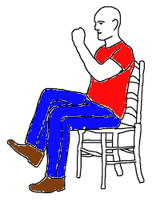  It was agreed that we should have another session of Yoga and Well Being as everyone thoroughly enjoyed the last event.  Claire suggested getting in touch with her friend who does exercise classes and would probably be interested in doing a class for us.    A request was made for Adult Learning to come again. Eddie pointed out that due to Adult Learning he has been on a course which runs on a Tuesday morning 10:00 – 12:30 and has found it very interesting. It was about history of Pubs and Restaurants in Melton and this information may go on to the Museum website so people can see it. Eddie informed everyone that there are over 290 business outlets in Melton .  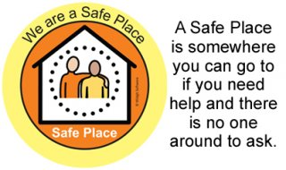  Jackie is going to check with regards to where the Keep Safe Places are and to make sure the stickers are displayed. It was suggested to contact the Chamber of Trade to discuss this with them and to explain how important these places are to vulnerable people in their community. The Museum is not a Safe Place building due to the fact that there is only ever one member of staff on duty.      Mencap are doing Round the World Challenge and have already been to another group to talk about it. This may be something we could look at and discuss. Marie will give Jackie a contact number to ring.  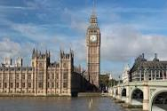  Jackie confirmed that she had invited Sir Alan Duncan MP for Melton and Rutland to our meeting but his Surgery Day is Friday so he would be unable to attend. Neil O’Brien, who is MP for Market Harborough, was also invited to the HAT group meeting and he suggested that we could possibly meet up when we have our visit to Houses of Parliament.  It has been confirmed that there will be a visit to the Houses of Parliament and names of those who want to go will be put into a hat - Jackie did point out that it will be an early start and there will be a lot of walking, and probably a late return.    When all this is sorted there will be a meeting at County Hall to put together some questions which will be sent prior to the meeting. It was suggested that one of the questions should be to ask MPs to make their correspondence more easy read friendly.  Helen, Heather, Eddie and Helen A confirmed that they would like to put their names forward to go to the Houses of Parliaments.    Jackie said that those who go on the visit would be asked to do a short presentation to the Partnership Board.  Any Other Business    After discussion it was agreed that invitations be sent out to people giving them information about our group and asking them to come along.  - Suggested that we had a visit to the Mayor’s Parlour.  - Jackie will get together with Helen at a later date to produce the Action Plan.  - Jackie will also discuss venues for future meetings with Helen.

Date of Next Meeting
Thursday 4 April 2019
1:30 - 3:30
Melton Carnegie Museum
Melton Mowbray
Leicestershire

